5. Architectural approaches

The project is based on the legendary client server architecture, where the server is sandwiched between the database and the application serving as an interface between the two.

The application is a web solution that allows for registration of new applicants to join Memphis University. Upon successful registration the admission panelist scrutinize all the application and shortlist successfully applicant who can monitor the status on the portal.

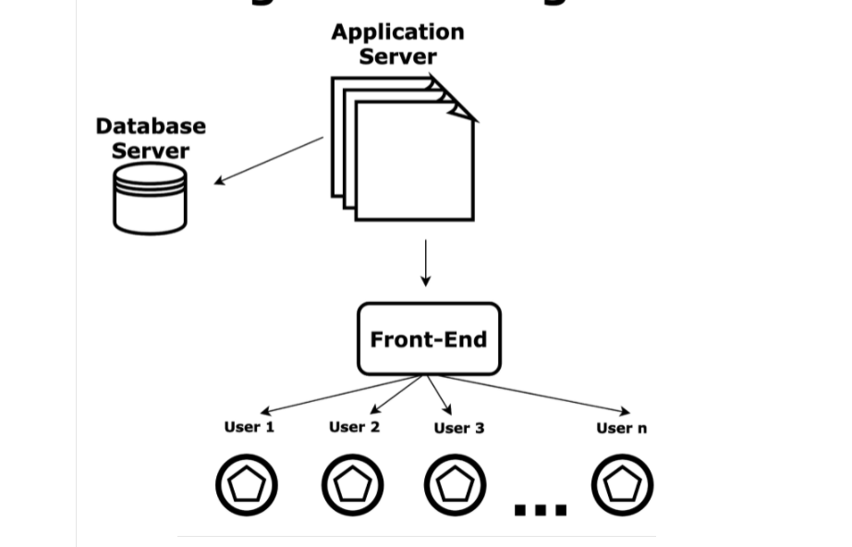

7. program design- application design, physical DFD, pseudo code

Application design

The use case below illustrates the application design where different actor as applicant and admission staff can interact with the application in activity as logging in registration and evaluation.

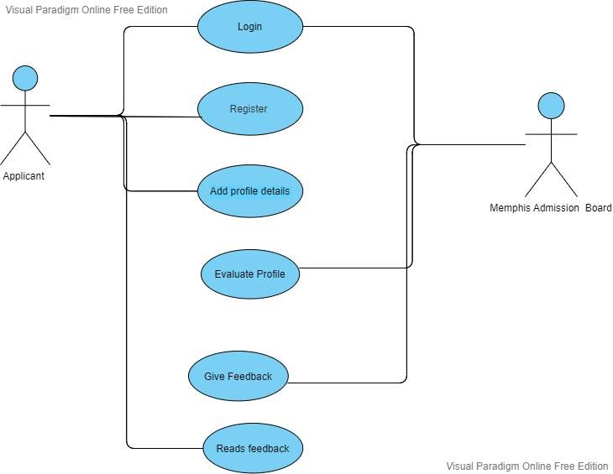

Flow chart diagram

The flow chart below simulates how the processing of data within the application is done.

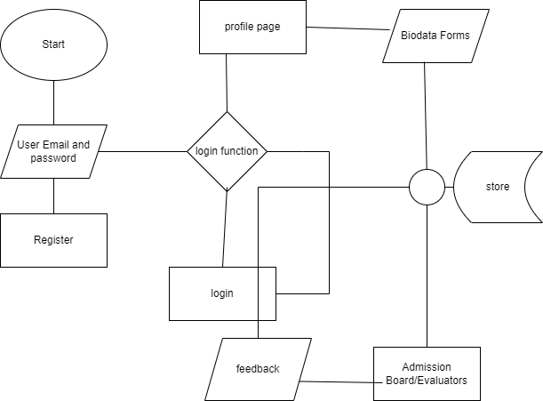

Pseudo code

* create a new user from registration forms
* while a user exist log him/her in
* add biodata of logged in users
* submit fully filled biodata information into the database
* admission board evaluate applicant’s eligibility
* admission gives feedbacks on admission of given applicant
* display evaluation feedback to the applicant

8 implementations: coding, milestones. Test plan and test schedules

the project was implemented as a web solution using HTML and CSS for markup and styling and JavaScript and PHP for client and server logic and mysql database.

The approach taken involved breaking the project into features which were independently developed and tested for easier verification and validation. This approach minimized complexity and overhead involved in later integrated testing. Additionally, effectiveness of the feature is ensured to preserve the motivation of the project.

Test plan

The testing that was conducted on the project fell under Unit testing, where functions and statement were comprehensively tested to ensure compliance with desired features. The methodology taken for unit testing involved identification of test criterion, development of test script and deduction of conclusion on conformance of the feature with desired goal.

Integration testing involves the overall behaviors of the integrated system. The conformance standard like predetermined test scripts and approach taken to conduct the test.

Test schedule

The test schedule involved identification of test milestones identified in a software project, it also involved estimation of time needed to complete every task as well identification of test resource that was needed to do the testing.

9 support plans:

Upon handing over the project to the owners a plan has been put into place to guaranteed continued running of the software solution. The mandate of support plan is to ensure correction, enhancement as well as adding new features to the system. These measure overlay improve efficiency and productivity gains on work environment, reduces downtime and stability the system and mitigate on threats.

The terms of the test plan are:

* Basic routine Maintenance, enhancement and security contracts
* Severity response commitment
* Customer care issues management and
* 24 x 7 support